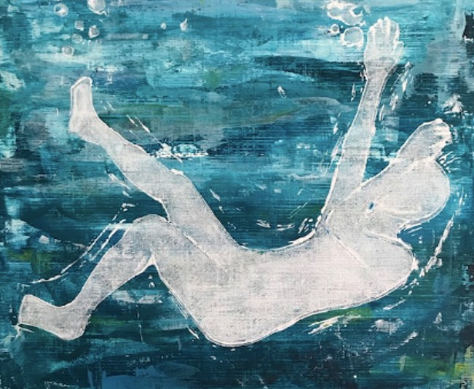

SCOTTISH MEDICAL HUMANITIES CONFERENCE

Image created by Carah Addison-Smyth
WEDS 14th June 2023
when a third year medical student in Aberdeen

ALL CHANGE!

New directions for Scottish Medical Humanities. Exploring the process, outcomes and possibilities through scholarship and creativity.
The day is intended to be inclusive and to reach a wide audience of healthcare, arts and humanities students, educators, researchers, practitioners and health professionals to join the Scottish Medical Humanities Group.
FREE networking event, with thanks to our sponsors

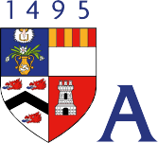

www.mddus.com George Washington Wilson Centre for Art and Visual Culture www.abdn.ac.uk/sdhp/gww-centre-2169.php

For further information and to register, please see Events at
www.scottishmedicalhumanities.org

